**DAILY ONLINE ACTIVITIES SUMMARY**

|  |  |  |  |  |  |  |  |  |
| --- | --- | --- | --- | --- | --- | --- | --- | --- |
| **Date:** | **27-05-2020** | | | | | **Name:** | **Preethi** | |
| **Sem & Sec** | **6th - B** | | | | | **USN:** | **4AL17CS065** | |
| **Online Test Summary** | | | | | | | | |
| **Subject** | | **System Software and Compiler Design** | | | | | | |
| **Max. Marks** | | **30** | | **Score** | | | **22** | |
| **Certification Course Summary** | | | | | | | | |
| **Course** | **Introduction to Information Security** | | | | | | | |
| **Certificate Provider** | | | **greatlearning** | | **Duration** | | | **5.5 hours** |
| **Coding Challenges** | | | | | | | | |
| **Problem Statement: 2 java and 1 C program** | | | | | | | | |
| **Status: executed** | | | | | | | | |
| **Uploaded the report in GitHub** | | | | | **Yes** | | | |
| **If yes Repository name** | | | | | <https://github.com/PreethiNayak/Daily-Status/tree/master/27May2020> | | | |
| **Uploaded the report in slack** | | | | | **Yes** | | | |

Online Test Details: (Attach the snapshot and briefly write the report for the same)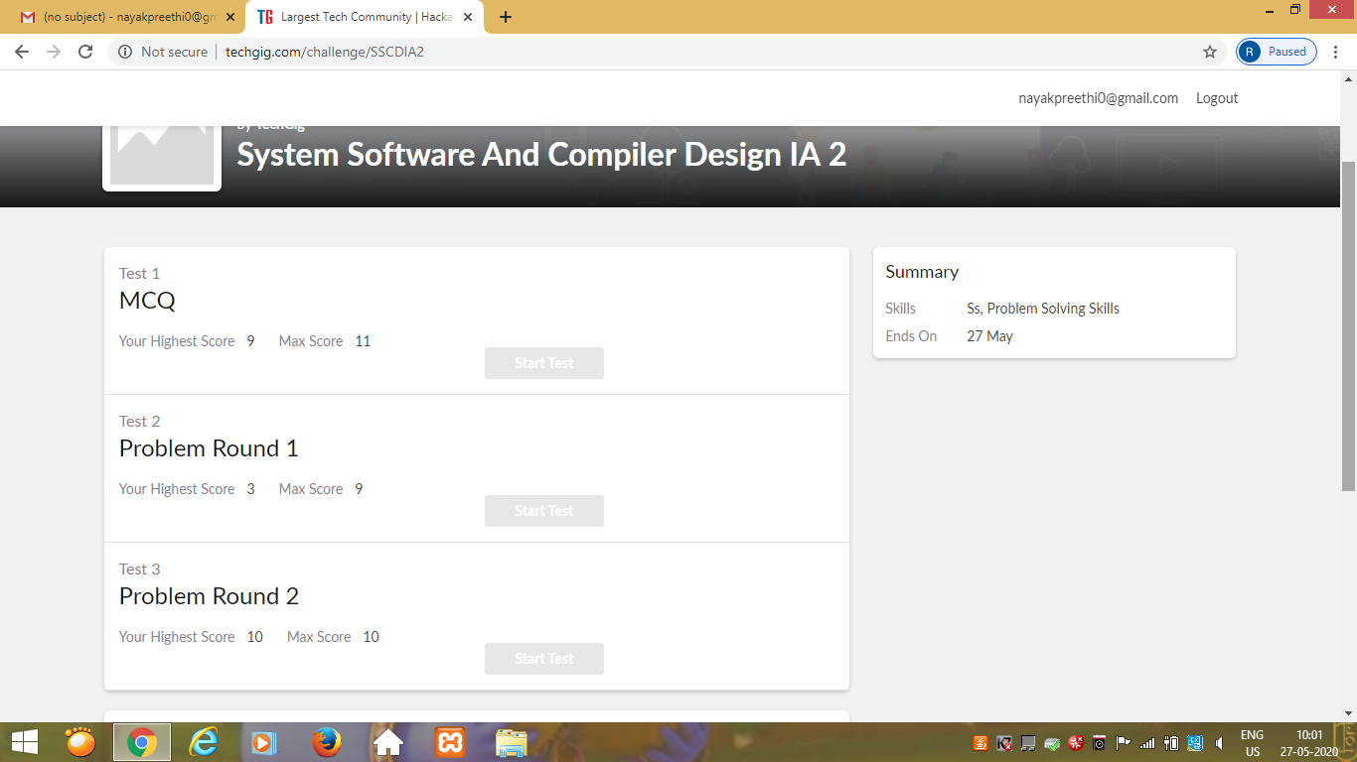

Certification Course Details: (Attach the snapshot and briefly write the report for the same)

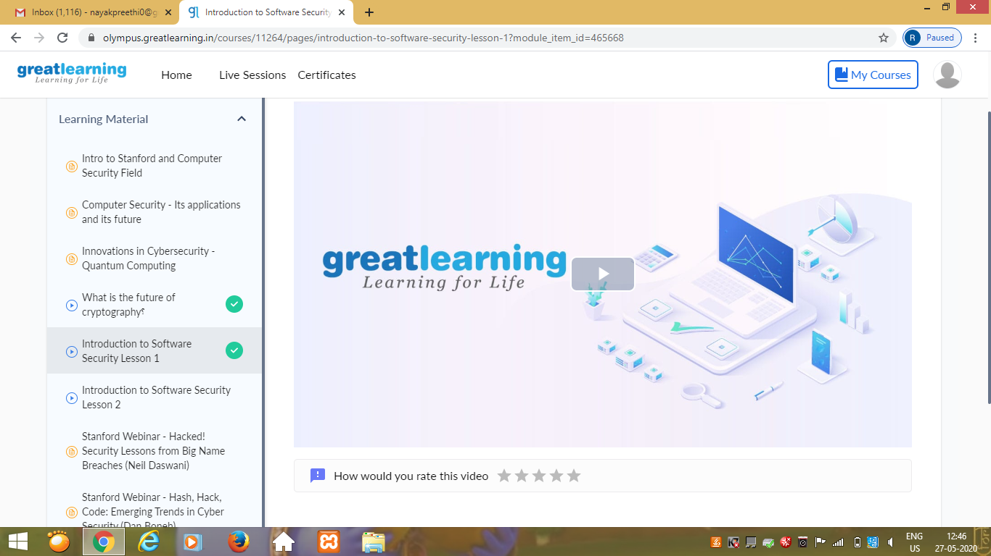

Today I learnt detailed information about “Introduction on Software Security Lesson 1”

In that I learnt,

1)Detailed description of Software Security

2)SILEX malware

Coding Challenges Details: (Attach the snapshot and briefly write the report for the same)

OUTPUT SCREEN-SHOTS

Program 1

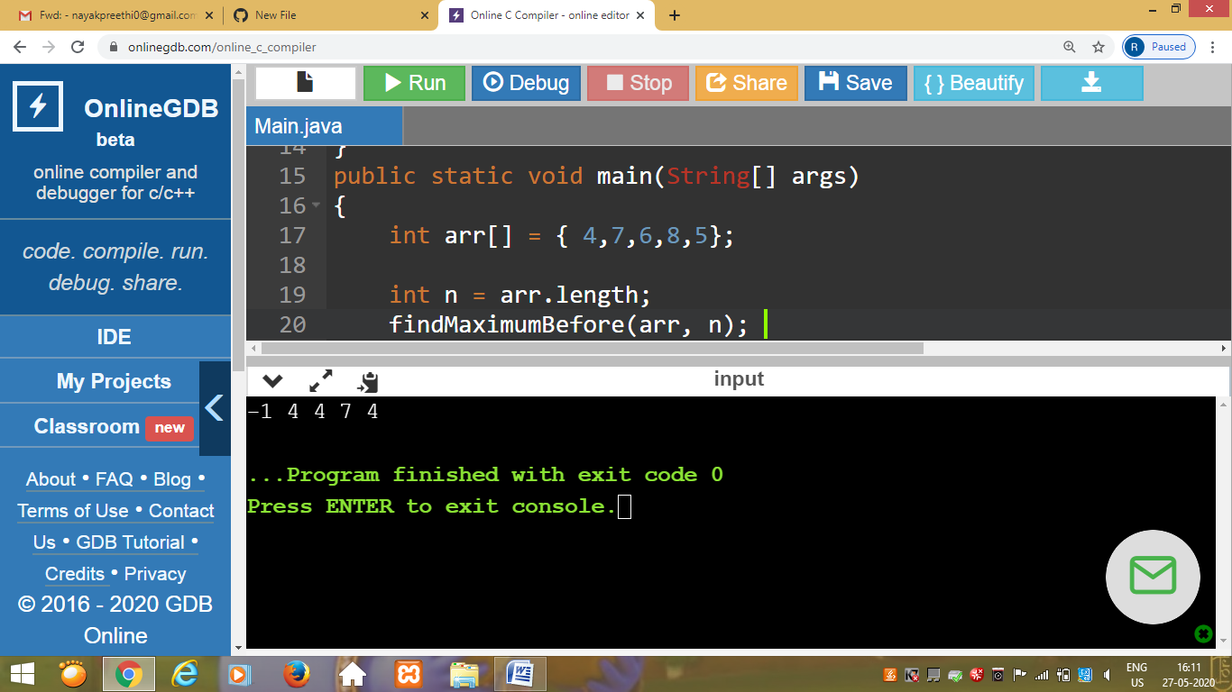

This is output of program to find the largest element on the left side of each index which is smaller than the element present at that index in the given array.

Program 2

This is the output of the program to sort the array elements using bubble sort.

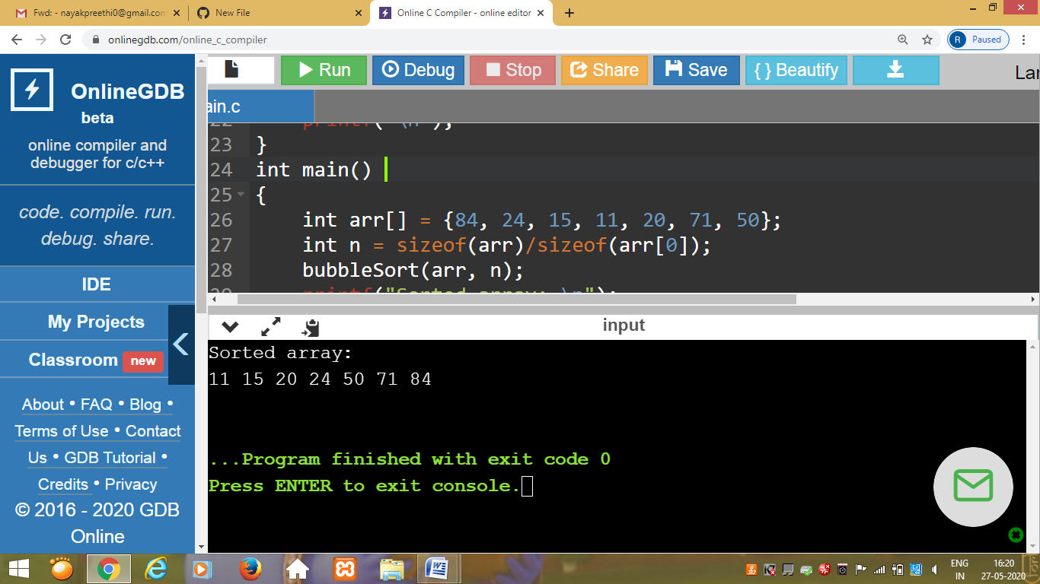

Program 3

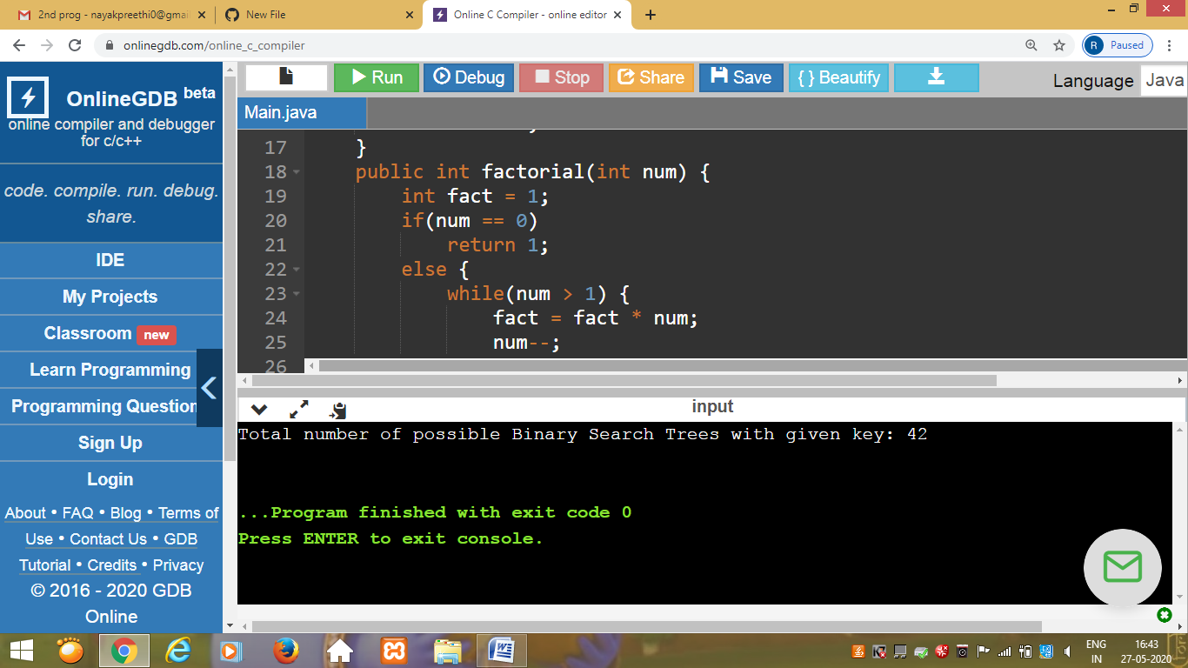

This is the output of the program to implement binary tree using linked list.